ACS Reading Group Guide
  - Teach Students How to Learn by Saundra Yancy McGuire

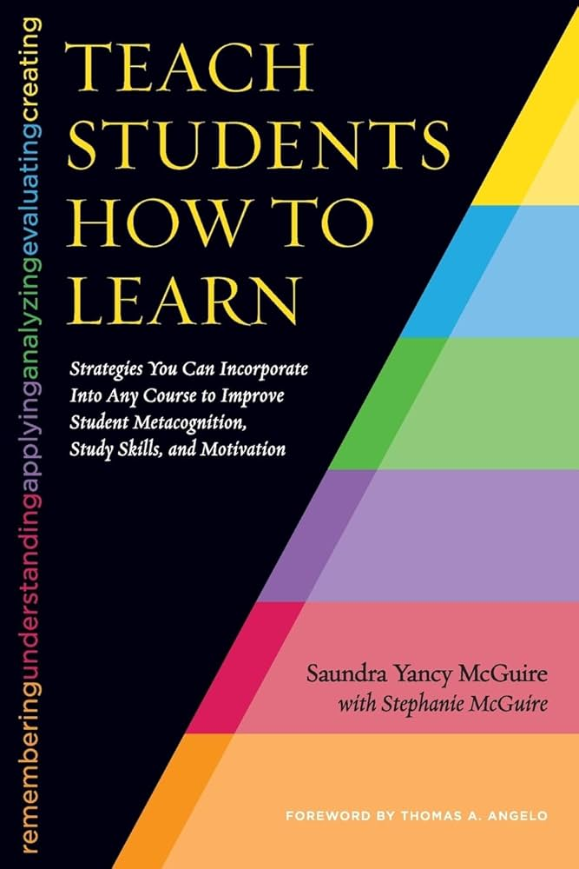

By Jean Schwab, Director of Peer Assisted Learning, Furman University
& Kelsey Harp, Director of Academic Success, Furman University
Summer 2024
Table of Contents
Introduction 4
Potential Reading Group Audiences 4
Potential Chapter Grouping for Reading and Discussion 4
Using this Guide 5
Chapter Summaries and Discussion Questions 5
Chapter 1: Saundra’s Journey: From Traditional Instructor to Academic Transformer 5
Summary 5
Discussion Questions 5
Beyond the Chapter 5
Chapter 2: Why Don’t Our Students Already Know How to Learn? 6
Summary 6
Discussion Questions 6
Beyond the Chapter 6
Chapter 3: Metacognition: What It Is and How It Helps Students Become Independent Learners 6
Summary 6
Discussion Questions 6
Beyond the Chapter 7
Chapter 4: The Power of Teaching Bloom’s Taxonomy and the Study Cycle to Students 7
Summary 7
Discussion Questions 7
Beyond the Chapter 7
Chapter 5: Metacognitive Learning Strategies at Work 8
Summary 8
Discussion Questions 8
Beyond the Chapter 8
Chapter 6: Mindset Matters 8
Summary 8
Discussion Questions 8
Beyond the Chapter 8
Chapter 7: Connections Between Motivation, Emotions, and Learning 8
Summary 8
Discussion Questions 9
Beyond the Chapter 9
Chapter 8: What Faculty Can Do to Boost Motivation, Positive Emotions, and Learning 9
Summary 9
Discussion Questions 9
Beyond the Chapter 10
Chapter 9: What Students Can Do to Boost Motivation, Positive Emotions, and Learning 10
Summary 10
Discussion Questions 10
Beyond the Chapter 10
Chapter 10: Partnering with Your Campus Learning Center 11
Summary 11
Discussion Questions 11
Beyond the Chapter / Overview for Facilitators 11
Chapter 11: Teaching Learning Strategies to Groups 11
Summary 11
Discussion Questions 11
Beyond the Chapter 11
Chapter 12: Teaching Unprepared Students 12
Summary 12
Discussion Questions 12
Beyond the Chapter 12

Introduction
Students entering college have experienced multiple years of learning disruption. The gap between those who are well-prepared for college and those who are not has widened in many ways. While learning disruption has more strongly impacted students from diverse backgrounds, all of our incoming students may need additional help being successful in college.

On many college campuses, study skills and academic success strategies are often taught in campus learning centers. In Teach Students How to Learn, Saundra McGuire argues that instructors can improve student learning and address achievement gaps by integrating these study skills and strategies directly into their classrooms. Faculty are often in the best position to identify students who are falling behind academically. By using the strategies in McGuire’s book, faculty can prevent students from falling behind in the first place by teaching students to: learn effectively; monitor and adjust their learning strategies; and take responsibility for their learning.

Potential Reading Group Audiences
This book may appeal to a variety of stakeholders on college campuses. Those who work in academic or student success programs would find it beneficial for their academic coaching, advising, and programming. Faculty may find it useful in their classes and advising. And tutoring or writing center staff can implement the strategies in their work with students.

Potential Chapter Grouping for Reading and Discussion
We have provided a chapter-by-chapter breakdown so that it will be easy for facilitators to adapt the guide for their own goals and meeting frequency.

With twelve chapters, the book divides nicely into three chapters per meeting across a total of four meetings. Divided this way, the chapters also fit together well thematically.

Chapters 1-3: The first three chapters set the stage by including background information about McGuire’s work with students (Ch. 1), why college students often don’t know how to learn (Ch. 2), and an explanation of metacognition (Ch.3) that serves as a foundation for the rest of the book.

Chapters 4-6: These chapters cover learning theories that can immediately help students see more effective ways to learn, such as Bloom’s Taxonomy and the Study Cycle (Ch. 4), specific metacognitive learning strategies (Ch. 5), and growth mindset (Ch. 6).

Chapters 7-9: The next three chapters focus on motivation, emotions, and learning, from an exploration of the connections between the three (Ch. 7) to what faculty (Ch. 8) and students themselves (Ch. 9) can do to improve all three.

Chapters 10-12: The final three chapters discuss practical tips for implementing the strategies found earlier in the book. These include how to partner with your campus learning center (Ch. 10), how to teach metacognitive learning strategies in a classroom setting (Ch. 11), and why unprepared students may find these strategies especially helpful (Ch. 12).

Using this Guide
Each chapter outline below has three sections.
Summary: A brief overview of the chapter’s contents
Discussion Questions: A list of questions to consider when facilitating discussion of each chapter
Beyond the Chapter: Additional context or points to consider that may be relevant but are not directly related to the chapter’s contents

Chapter Summaries and Discussion Questions

Chapter 1: Saundra’s Journey: From Traditional Instructor to Academic Transformer

Summary
In Chapter 1, McGuire outlines her own educational background and how she came to embrace the value of teaching learning strategies to students. She looks back on her own time as a student and connects what she knows now about learning to her own behaviors as a student who only studied the night before the test.

Discussion Questions
- Why is this book/topic appealing to you? What are you seeing in your students?

Beyond the Chapter
- Students are coming to college both less prepared and with a wider range of preparation levels. Our goal should be to help them become independent learners who are comfortable with the productive struggle of learning.
- Faculty can approach learning strategies through their discipline (e.g., reading a chemistry textbook is different than reading a philosophy text and students should have different strategies depending on context).

Chapter 2: Why Don’t Our Students Already Know How to Learn?

Summary
Chapter 2 explores why students entering college don’t know how to learn. McGuire draws a connection between what students are told prior to college (that middle school will be harder than elementary school; that high school will be harder than middle school) and how students’ experiences are often different (and therefore they don’t see evidence that anything is getting harder). Students understandably do not see any connection between their own effort and their performance on assessments.

Discussion Questions
- Why focus on learning instead of teaching?
- What does it look like to focus on learning instead of teaching in your discipline?
- Why don’t many students need to study in high school?
- What differences might exist now (post-pandemic) compared to when the book was written in 2014?

Beyond the Chapter
- Educators should be more explicit with expectations and in their teaching.
- We should challenge our previous assumptions about students and what we think they should know entering college (especially those based on our own experiences in high school).
- Mental health concerns and poor time management seem to be at an all-time high.
- Consider what it looks like to focus on learning instead of teaching in different disciplines.

Chapter 3: Metacognition: What It Is and How It Helps Students Become Independent Learners

Summary
Chapter 3 explains the concept of metacognition, that is, thinking about one’s own thinking. McGuire presents an activity, Count the Vowels, that demonstrates the effect that metacognition has on learning and argues that students very often don’t match their learning strategies to the learning task before them.

Discussion Questions
- How can we change the way we view students and their work ethic?
- What was your experience with learning how to learn?
- Think back to when you were first starting college. What strategies did you use to learn new material? Did they work? Why or why not?
- In your interactions with students what are their sticking points? What are they struggling with the most?

Beyond the Chapter
- Be vulnerable with your students – talk through some of the things that you struggled with and how you approached college work.
- At what point did you begin to see yourself as an expert in your discipline?
- Who are the students in your classes and how might their reason for taking a class impact their approach to learning? First-year students seeking general education credit? Declared majors who will need this content in future classes? Interdisciplinary students taking an elective?
- For additional examples of the power of metacognition, see this video of McGuire: https://www.youtube.com/watch?v=n_A6BZOUOts
  - “A newspaper is better than a magazine” example at 48:21 - https://youtu.be/n_A6BZOUOts?si=R931nji8EC0Dcsek&t=2901
  - “Finding numbers” example at – 1:01:45 - https://youtu.be/n_A6BZOUOts?si=PkVtluMbXVRk3Vf4&t=3705

Chapter 4: The Power of Teaching Bloom’s Taxonomy and the Study Cycle to Students

Summary
Chapter 4 explains Bloom’s Taxonomy and the study cycle. She also advocates for teaching students about both, asking them to reflect on where in Bloom’s Taxonomy they have been operating so far in their education, and telling students how to use the study cycle to improve their learning.

Discussion Questions
- How would you approach teaching students about Bloom’s Taxonomy? The Study Cycle?
- What level of Bloom’s are your students operating at and where do you want them to be?

Beyond the Chapter
- Consider building in time to review and teach strategies. For example, build in space in your class calendar to review the first assessment. Walk through some metacognitive strategies with students in preparation for the next exam/assessment.
- You can also show students how you take notes while reading – which is a form of paraphrasing and could show students how to be strategic readers.
- Are there disciplinary-specific approaches or types of content that map onto Bloom’s Taxonomy?
- How might the Study Cycle apply in the structure of your classes and assessments?

Chapter 5: Metacognitive Learning Strategies at Work

Summary
Chapter 5 outlines specific metacognitive learning strategies that students can use in their courses. Examples include active reading strategies, using homework to assess their progress, and teaching others to ensure mastery of content.

Discussion Questions
- What are ways that faculty members can design their syllabus and daily class structure to reinforce effective learning habits?
- Let’s say you are going to teach your students how to better prepare for their next test. In your discipline, which strategies would recommend?

Beyond the Chapter
- Encourage students to share their strategies with their peers. Use class time to create questions for a shared study guide.
- Are there strategies that you think might not work at all for your discipline? What are they and why might they be ineffective?

Chapter 6: Mindset Matters

Summary
Chapter 6 describes the difference between a growth mindset and a fixed mindset. McGuire also describes how faculty can encourage students to develop a growth mindset.

Discussion Questions
- What mindset do students most often bring to your subject matter or space?
- How does this connect back to Bloom’s Taxonomy?

Beyond the Chapter
- It can be a challenge to convince risk-averse students who have a fixed mindset can; keep providing opportunities and encouragement.
- Consider having a variety of formative and summative assessments.

Chapter 7: Connections Between Motivation, Emotions, and Learning

Summary
Chapter 7 discusses the connections between motivations, emotions, and learning. McGuire talks about what motivation is, what influences motivation, and why it can be an educator’s responsibility to foster motivation in students.

Discussion Questions
- Chapter 7 lists levers that influence student motivation (pg. 74, figure 7.2). Do you feel like these are accurate? In your experience, is one of these levers more of a sticking point than others?
- How can we encourage students to see that participating in rich learning experiences will provide real-world skills and value?

Beyond the Chapter
- Academics already believe in that value of learning for its own sake, but it can be hard for students to see the benefits.
- Sometimes students see courses as steppingstones. They often focus more on the bigger picture instead of the learning in front of them.
- It takes time and experience to develop one’s belief in their ability to succeed.
- This chapter presents another opportunity to discuss who is in your class and why they are there. How can you connect with what is motivating them to be in your class?

Chapter 8: What Faculty Can Do to Boost Motivation, Positive Emotions, and Learning

Summary
Chapter 8 explores strategies for fostering motivation. McGuire provides twenty-one specific strategies for increasing student motivation. She also explains that faculty should not plan to implement all strategies but that adopting a few strategies throughout the semester can make a big difference in students’ motivation.

Discussion Questions
- How do you create a motivating / supportive environment?
- How do you find out if the environment is not supportive?
- Figure 8.2 discusses autonomy. What do you do in your course to encourage student autonomy?
- (Metacognition metaphor) Figure 8.4 is a photo of a four-door car in which the door handles on the back doors are in a different location than those on the front doors. This is yet another example that how we approach a problem and the information we have sets the stage for success. If you think that the car has two doors, then you won’t question the fact that you can’t see handles in the expected place on the back doors. You won’t even look for them. If you think that the car has four doors, then you know that there should be handles on the back door. When you do not find them in the expected location, you know to look elsewhere.
  - What are the hidden assumptions in your classes and discipline that can confuse students?

Beyond the Chapter
- Pre-course questionnaires can allow faculty to learn more about students in a low-stakes way.
- Be explicit and provide detailed rubrics.
- Explain why students earned their grade (and use language that reflects that instructors do not just “give” grades; students “earn” grades through their actions).
- Consider changing language in your syllabus to improve transparency and clarity (e.g., call rename “office hours” to visiting hours so students know they are welcome).
- Allow students to have a say in assignments when possible (e.g., the class can help create the rubric) but set boundaries.
- Collaboration can help increase individual autonomy.
- Flexibility may not always be possible in STEM courses or other content-heavy courses. Instead, have students teach some of the course content in small groups following the lecture or work on application problems in teams.
- Talk about “goals for the week” on the first day of class for the week or at the beginning of a new content section.

Chapter 9: What Students Can Do to Boost Motivation, Positive Emotions, and Learning

Summary
Chapter 9 is geared toward students and how they can increase their motivation. Educators can and should present these strategies to their students. McGuire also talks about how a growth mindset is conducive to learning and success.

Discussion Questions
- Anything in chapter 9 that is weighing heavy? Need to discuss?

Beyond the Chapter
- Because this chapter reviewed similar information as the previous chapter, but from a student perspective, we used the opportunity to revisit topics that may not have had enough discussion time in previous meetings.
- The type of discipline it takes for students to learn metacognitive strategies is time intensive. Some students may not be able to “cut back” on their out-of-class commitments (i.e. work, caring for others, etc.). How can we be supportive and maintain academic rigor?
- Sometimes it can be helpful to have a conversation about the process and product of learning and grades – sometimes we DO just have to get through it whether we feel motivated or not.
- Larger, structural factors that are beyond the scope of faculty expertise can impact student learning.

Chapter 10: Partnering with Your Campus Learning Center

Summary
Chapter 10 discusses the importance of connecting with your campus learning center for support. Professionals in these types of centers can provide student and faculty support with metacognitive strategies.

Discussion Questions
- Have you had the experience with partnering with campus resources / campus learning center? If not, after reading this book, how might you collaborate with partners on your campus?
- Many of the tips provided seem so simple to us, but they represent tasks that students have never had to do on their own and so they never learned how (e.g., their schedule was dictated to them in high school, so they have not had to keep a calendar to manage their time; or they may never have seen or written professional emails). What other skills do we assume our students have that they might not have (and for good reason)?

Beyond the Chapter / Overview for Facilitators
- Targeted, specific workshops that respond to a specific need may be better attended by both students and faculty.
- In-class workshops may also be helpful so students can see a connection to their coursework.
- Getting “buy in” for nonmandatory work can be difficult for student – rebrand the work and integrate learning strategies (e.g., the earlier suggestion of using an exam review session as a chance to teach metacognitive strategies).

Chapter 11: Teaching Learning Strategies to Groups

Summary
Chapter 11 is a step-by-step guide to teaching a 50-minute session on metacognitive and learning strategies. This is particularly helpful to teaching these types of strategies to larger groups of students. McGuire also provides some outside references that can be helpful for educators. While the chapter focuses on an intervention for a chemistry class, the session can be adapted for any discipline.

Discussion Questions
- Learning Strategies Intervention: What did she suggest that you agree with or what are some things that you would adjust if presenting to your students? (See Appendix H for full slides)

Beyond the Chapter
- Giving up an entire lecture can difficult when needing to teach content
- Offer extra credit sessions before the next test to review metacognitive strategies – but call it an exam review!
- What constraints do you face when it comes to teaching these strategies into your own classes (e.g., shared syllabi across sections/instructors; amount of content to cover)?

Chapter 12: Teaching Unprepared Students

Summary
Chapter 12 focuses on teaching unprepared students. McGuire draws on strategies from another scholar (Kathleen Gabriel) focusing on students who might feel less prepared for their assessments. She also focuses on meeting students where they are and understanding that there may be more to a student’s story than just academics.

Discussion Questions
- Students may be overcommitted to “important to them” things, but these are not always things that they just can set aside (e.g., family obligations, jobs, leadership positions on campus, internships, or socializing that serves as a foundation for a future professional network as they move into the working world). How can we help them navigate these different competing interests? How can we show empathy?

Beyond the Chapter
- Be willing to integrate high levels of support depending on student need but within boundaries of being a faculty member
- Academics don’t always have the whole story; be willing to refer students to appropriate resources

