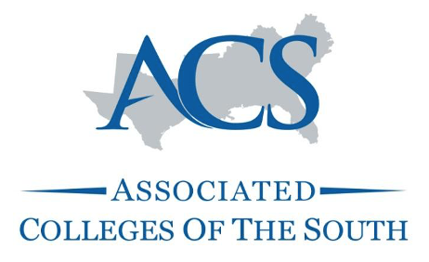
Grants Program Preproposal Form
Grant Cycle 8: May 1, 2021 – May 1, 2022
Primary grant theme:

☐Innovative Instruction | ☐Collaborative Curriculum | ☐Diversity and Inclusion

ACS is looking for evidence of project cohesion, relevance to the grant, and follow-through. The total length of your description should not be longer than 1 page. Please include a proposed budget following your description.

Email your completed preproposal to grants@acsouth.edu February 17, 2021 by 12pm ET.

We will conduct short, recorded interviews for each abstract submitted
to aid in finding collaborators. Interviews will be scheduled upon submission and
conducted through February 19, 2021.

Name of project lead:
Title/Department:
Email address:
Telephone number:
Institution:
Institution address:

Project title:

Provide a one-page abstract that briefly describes the project, lays out the initial goals, summarizes the methodology to be used, and outlines the desired outcomes. (While we recognize that the project will potentially shift a bit once collaboration begins, but we want to understand what you are hoping to do, how you are hoping to do it, and what you hope to see as a result.)

Provide a simple, estimated budget.

